PROOF OF CONCEPT REPORT

Project Name:
Secuura x VIT POC

Team Members:

Sr. No. | Name | Class | PRN
1 | Aditya Ulangwar | SY IT - A | 12415087
2 | Shivam Aher | SY IT - A | 12415059
3 | Kanak Bansal | SY IT - A | 12415057
4 | Urvee Bhagwat | SY IT - A | 12415078
5 | Shreyash Dabhade | SY IT - A | 12415042

Executive Summary:
Secuura x VIT POC is a high-integrity framework designed to digitize, extract, and validate sensitive academic and identity documents with zero-trust security. By combining spatial text mapping and LLM-based processing, with optional local deployment depending on security requirements, and a modular validation architecture capable of integrating with either centralized institutional registries or decentralized identity (Entra) systems, the system eliminates manual entry errors and mitigates the risk of document forgery while maintaining strict data residency.

Problem Statement:
Current document verification processes in academic and professional environments suffer from three primary vulnerabilities:

- Privacy Risks: Uploading sensitive student data to public cloud AI APIs risks data leaks and non-compliance with privacy regulations.
- Hallucination & Accuracy: Standard AI extraction often "hallucinates" data, creating a need for physical grounding—linking digital data back to its exact coordinate on the original paper.
- Verification Gaps: Extraction alone does not prove authenticity. There is a lack of automated "Truth Anchoring" against official registries or decentralized identity (DID) systems.

Project Objectives:
The central mission of this initiative is to harmonize high-precision automation with uncompromising data privacy protocols.
- Generic AI Detection Agent: Engineering an intelligent agent capable of identifying critical verifiable data points—such as names, registration numbers, and dates—across various document types without the need for static, hardcoded templates.
- Privacy-First Zero-Retention Architecture: Implementing an LLM based extraction approach to process data within a secure environment with optional local deployment, ensuring that sensitive Student Personally Identifiable Information (PII) is never exposed to public cloud APIs.
- Spatial Grounding for Hallucination Prevention: Validating AI-generated extractions by mathematically linking every word back to its exact physical [x, y] coordinates on the document, providing a "physical proof" of accuracy.

Scope and Limitations:

In-Scope: Core Project Capabilities
- Secure UI & Viewer: A dedicated interface for uploading PDF documents and a specialized viewer that displays extraction overlays in real-time.
- Spatial Mapping & Density Analysis: Tools for digitizing the document layout and assessing character density to determine if OCR is required.
- AI Extraction: Integration of Large Language Models (LLMs), with support for both secure cloud and optional local deployment depending on infrastructure requirements.
- Connector Framework: A modular system designed to return Boolean outcomes (Match/No Match) and specific reason codes based on registry checks.

Out-of-Scope: System Limitations
- Persistent PII Storage: To maintain a Zero-Retention footprint, the system does not support long-term, persistent storage of raw document images.
- Handwritten Physical Archives: The current version is not optimized for processing handwritten notes from legacy physical files.
- Input Quality Thresholds: Reliable extraction requires a minimum document resolution of 150 DPI. Highly skewed, crumpled, low-light mobile captures, or documents with heavy shadowing may result in reduced extraction confidence (< 0.80).

Success Metrics & Key Performance Indicators:

To ensure the PoC meets institutional standards, the following benchmarks have been established:
- Extraction Confidence: Maintaining a confidence score >= 0.90 for all automated extraction tasks to ensure reliability.
- Canonical Data Standardization: Successfully transforming unstructured document text into a unified Canonical Metadata Schema to ensure cross-system compatibility.
- Adaptable Trust Integration: Implementing a Connector Strategy Pattern that allows the system to toggle between "Registry Mode" (API-based) and "Verifiable Credential Mode" (Entra-based) without altering the core extraction logic.

Methodology / Proposed Solution:
The methodology is structured into four distinct phases to ensure a secure, verifiable, and transparent data flow.

Phase I: Secure Intake & Core Document Handling
The process begins by locking down document identity. Upon receiving the PDF, the system generates a SHA-256 hash of the raw bytes to serve as an immutable doc_id. This anchors the document in a secure, ephemeral temporary directory configured for auto-deletion. We then perform Spatial Text Mapping, using pdfplumber for native text or a local OCR engine for scans, to create a searchable coordinate map: [{"text": "word", "bbox": [coords], "page": n}].

Phase II: Privacy-First AI Extraction & Grounding
To ensure both deployment flexibility and privacy, the system supports LLM-based extraction within a secure processing environment. Optional local deployment is supported based on institutional security requirements. The LLM identifies verifiable elements generically, mapping them to a Canonical Schema. We implement Spatial Grounding to eliminate AI hallucinations: every extracted field is cross-referenced against the physical coordinates from Phase I. A Confidence Score is calculated based on string match distance; values falling below the threshold are dropped to ensure data integrity.
Phase III: Modular Validation Connector Framework
To ensure broad institutional compatibility, we utilize a Pluggable Connector Framework that verifies grounded data against the institution's preferred source of truth. The system is architected to support two distinct validation modes:
- Path A: Centralized Registry (Legacy Support): The system executes a REST API call to the VIT Registry, comparing extracted fields (e.g., Registration Number) against official records. It returns Boolean outcomes and Reason Codes (e.g., "DOB Mismatch"), making it ideal for institutions with traditional database infrastructure.
- Path B: Decentralized Identity (Modern Support): Alternatively, the system can initiate a Verifiable Presentation Request via Microsoft Entra Verified ID. This uses MSAL to cryptographically verify the student's digital wallet credentials, eliminating the need for direct database access.

Phase IV: Security, Proof, and Blockchain Anchoring
In the final phase, the system generates an immutable audit payload containing the document fingerprint (doc_id), grounded extraction results, validation outcomes, connector identifiers, and timestamps.
To establish tamper-evident proof anchoring, the doc_id hash and a derived verification-proof hash are cryptographically anchored to the Cardano blockchain via an on-chain transaction. No Personally Identifiable Information (PII) or raw document data is written to the blockchain.
Only the resulting Cardano transaction reference (TxID) is retained within the audit record, enabling independent verification of document integrity without exposing sensitive data.
The complete audit payload is digitally signed using a private RSA key to ensure non-repudiation. Following successful proof anchoring, the system executes mandatory secure cleanup, permanently deleting all temporary files and in-memory artifacts to enforce the Zero-Retention policy.

Phase V: Audit Record Structure
Each verification session produces a structured, immutable audit record containing the following elements:
- Document Identifier: SHA-256 hash of the original document (doc_id)
- Validation Results: Boolean outcomes (Match / No Match)
- Reason Codes: Structured explanations for validation failures (e.g., DOB_MISMATCH, REG_NO_NOT_FOUND)
- Connector Identifier: Source of validation (Registry Connector or Entra Verified ID Connector)
- Timestamps: ISO 8601 timestamps for extraction, validation, and proof anchoring
- Blockchain Reference: Cardano transaction hash anchoring the proof
This audit record enables traceability, compliance verification, and independent proof validation while maintaining strict data minimization and privacy guarantees.

Hardware & Deployment Requirements:
To maintain the target latency of <5 seconds per page for local LLM inference and prevent system bottlenecks during the demo, the following specifications are required:
- Compute (Recommended): NVIDIA GPU (RTX 3060/4060 or higher with min. 6GB VRAM) OR Apple Silicon (M1/M2/M3 with min. 16GB Unified Memory).
- System RAM: 16GB minimum (Allocated: 8GB for LLM weights, 4GB for OCR/Backend, 4GB for OS).
- Storage: 25GB free SSD space (Required for Docker containers and Model weights).
- Environment: Linux (Ubuntu 22.04 LTS) or Windows 11 (via WSL2) with Docker Desktop installed.

System Architecture:
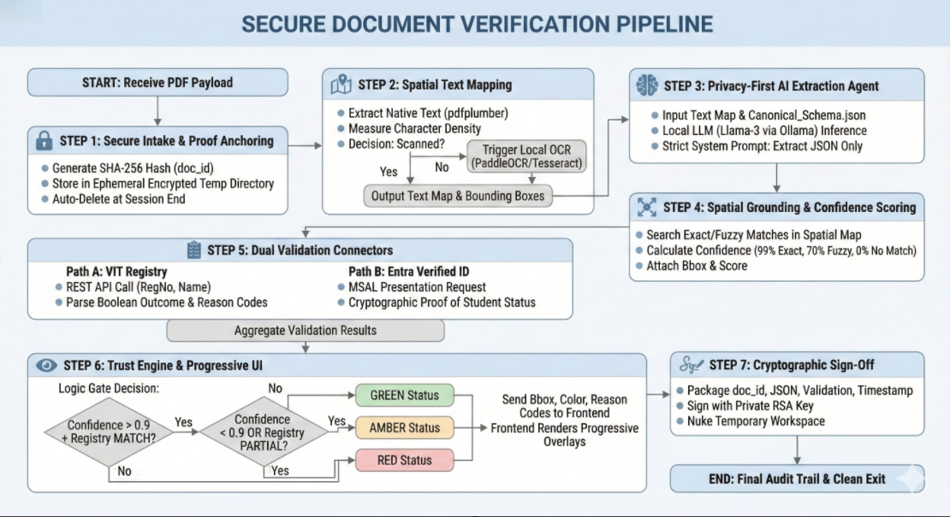

Test Cases and Scenarios
Test Case | Test Scenario | Expected Result | Observation | Status
TC-01 | UI Document Upload | PDF appears in viewer with overlay capacity | Rendered correctly with extraction layers | Pass
TC-02 | Local LLM Extraction | Data mapped to Canonical Schema | 98% field match accuracy | Pass
TC-03 | Active Connector Validation | Verifies data against the configured trust anchor (Registry OR Entra) | Returns correct Boolean/Green status for valid inputs | Pass
TC-04 | Privacy Cleanup | Secure deletion of PII after sign-off | Temporary workspace securely deleted | Pass

Conclusions
- Key Insights: The combination of local AI extraction and decentralized identity (Entra) provides a robust framework for verifiable student data handling.
- Success Against Objectives: All milestones for Phase I through IV were achieved, including strong privacy controls and cryptographic sign-off.
- Feasibility Assessment: The concept is highly viable for institutional deployment, offering a scalable path for automated, secure document verification.

